

Online Book Management System

Submitted By
Anubhav Yadav
25MCD10057
25MCD-2 (A)

Submitted To
Er. Prabhjot Kaur
(E17274)

in partial fulfilment for the award of the degree of
Master of Computer Applications (Data Science)

Chandigarh University

Jul 2025 – Dec 2025

ACKNOWLEDGEMENT

We deem it a pleasure to acknowledge our sense of gratitude to our project guide, Er. Prabhjot Kaur (Assistant Professor, UIC) under whom we have carried out the project work. Her incisive and objective guidance and timely advice encouraged us with constant flow of energy to continue the work.
We wish to reciprocate in full measure the kindness shown by Dr. Krishan Tuli (H.O.D, University Institute of Computing) who inspired us with his valuable suggestions in successfully completing the project work.
We shall remain grateful to Dr. Manisha Malhotra, Additional Director, University Institute of Computing, for providing us a strong academic atmosphere by enforcing strict discipline to do the project work with utmost concentration and dedication.
Finally, we must say that no height is ever achieved without some sacrifices made at some end and it is here where we owe our special debt to our parents and our friends for showing their generous love and care throughout the entire period of time.
Date: 07/11/2025
Place: Chandigarh University, Mohali, Punjab.
By: Anubhav Yadav, UID- 25MCD10057.

INTRODUCTION
The Online Bookstore Management System is a comprehensive web application designed to facilitate the browsing, searching, and purchasing of books online. This project serves as a practical demonstration of integrating server-side application logic with robust database management, emphasizing the capabilities of PL/pgSQL for handling core business operations. The system provides a seamless experience for both customers (for registration, browsing, shopping, and ordering) and administrators (for inventory management and reporting). By implementing secure user authentication, a transactional shopping cart, and automated order processing, the system simulates a real-world e-commerce environment.

OBJECTIVES
The primary objectives of this project are to develop and demonstrate proficiency in the following areas:

1. Database and PL/pgSQL Implementation
- Implement Business Logic in the DB: Develop stored procedures, functions, and triggers (using PL/pgSQL) to manage all complex, transactional operations directly in the database.
- Ensure Data Integrity: Utilize triggers to automatically manage inventory stock levels upon order placement and calculate order totals, ensuring data consistency and preventing negative stock quantities.
- Enable Efficient Searching: Create a dedicated search function to allow users to quickly find books by title or author, optimizing query performance.

2. Core Functional Features
- User Management: Implement secure user registration and login mechanisms, along with the ability for users to view their profile details.
- Shopping Cart System: Provide users with the ability to add books to a cart, update item quantities, and remove items before proceeding to checkout.
- Order Management: Develop a procedure to handle the complex checkout process, moving items from the cart to a new order and recording the transaction details.
- Book Management (Admin): Provide administrative functionality to add, update, and remove book details and manage stock quantity within the inventory.

3. Application Interface and Architecture
- Front-End Development: Utilize HTML and CSS (specifically Tailwind CSS, as implemented in the refactoring) to create a clean, responsive, and user-friendly interface.
- Backend Integration: Use the Flask framework (Python) to serve as the secure intermediary, handling user sessions, routing requests, and communicating reliably with the PostgreSQL database.
- Reporting: Implement administrative reports to provide insights into sales performance and low-stock inventory, aiding in business decision-making.

LITERATURE REVIEW
Developing a modern Online Bookstore Management System requires integrating several established technologies and best practices from e-commerce and database literature. This review grounds the project in studies related to three primary areas: Automated Billing and E-commerce Systems, Database Management (DBMS) with PL/pgSQL, and Front-End User Experience.

I. Automated Billing and E-commerce Systems
The literature consistently highlights that manual billing processes are prone to errors, time-consuming, and costly. Automated billing systems directly address these issues by enabling fast, accurate, and scalable invoicing and payment processing.
- Accuracy and Efficiency: A core principle is the automation of complex calculations involving pricing, discounts, and taxes. By performing these calculations with pre-defined rules, the system ensures every record is accurate and consistent, which is crucial for financial integrity.
- Operational Efficiency: Automated invoice generation, payment tracking, and reporting free up employee time to focus on customer support and business growth.
- Scalability: For systems designed to handle growing transaction volumes, scalability is essential to maintain performance. The architectural design must support growth without requiring significant overhauls.

II. Database Management and PL/pgSQL
This project uses PostgreSQL as the database management system (DBMS) , which is frequently chosen due to its robust structured query capabilities and data integrity features.

- PL/pgSQL Logic (The Core Difference): By implementing stored procedures, functions, and triggers (PL/pgSQL), the project adheres to the principle of moving critical business logic (like updating inventory and calculating totals) directly into the database layer. This ensures that the logic is executed atomically and consistently, regardless of the application's state.
- Data Integrity (Triggers): Triggers are essential for maintaining data integrity and accountability. In this context, a trigger running after an order is placed ensures stock quantities are immediately reduced and prevents negative stock, demonstrating strong transactional control.
- Security Protocols: Billing systems manage sensitive data; therefore, using a secure, robust DBMS is critical. This approach enforces security through database access controls and transaction logging.

III. Front-End Interface and Usability
The user interface (UI) is the customer-facing component, influencing satisfaction and adoption.
- Technology Choice: User interfaces for web applications are typically designed using HTML/CSS, JavaScript, and frameworks like React or Angular. This project uses Flask with Jinja2 templates and Tailwind CSS to achieve a responsive, user-friendly interface.
- Customer Experience: Studies show that a smooth and transparent billing process improves customer satisfaction. The system achieves this through clear invoices, easy navigation, and self-service features like viewing order history.
- Minimal Learning Curve: A key non-functional requirement is ensuring the interface is intuitive and user-friendly with a minimal learning curve, which is addressed through clean, modern web design principles.

REQUIREMENTS
- Functional requirements (F.R) define what the system must do to meet user and business needs.

User Management and Authentication
- Registration: Users must be able to register by providing a name, email (must be unique), password, and address¹.
- Login/Logout: Registered users must be able to securely log in and log out of the system using their credentials.
- Profile Management: Users must be able to view and update their contact information and address details.

F.R. 2: Book and Inventory Management
- Add/Update/Remove Books (Admin Only): Administrators must be able to add new products, update book details (title, author, category, price, quantity/stock levels), and remove existing books from the system².
- Inventory Tracking: The system must track inventory levels for all books and notify the administrator of low stock levels (as seen in the reporting feature)³.
- Search and Browse: Customers must be able to search for books based on different criteria, including title or author.

F.R. 3: Shopping Cart and Checkout
- Add to Cart: Customers must be able to add books to their shopping cart while browsing.
- Update/Remove Cart Items: Customers must be able to update the quantity of items in their cart or remove items altogether.
- Checkout Process: The system must allow users to proceed to checkout, which initiates the order placement procedure.

Order Management and Transaction Processing
- Place Order: The system must execute the place_order procedure to create a new order record, move items from the cart to the order_items table, and clear the cart.
- Order History: Users must be able to view their complete order history, including the order date, status, total amount, and itemized list of products purchased⁴.
- Automatic Stock Update: The system must automatically reduce book stock (quantity) in the books table immediately after items are successfully inserted into order_items (via database trigger).

- Non-functional requirements (N.F.R) specify criteria used to judge the operation of a system, rather than specific behaviors.

Security and Integrity
- Authentication & Authorization: Database access must be secure, differentiating between Customer roles (read/write on cart/orders) and Admin roles (full inventory management access).
- Data Integrity: The system must apply constraints (like unique emails) and use database triggers to enforce business rules (e.g., preventing stock quantity from becoming negative).
- Encryption: Sensitive data (passwords, customer info) should be stored securely and encrypted (though simplified for this project, the requirement holds).

Performance and Reliability
- Response Time: The system should exhibit quick response times for all user actions, particularly searching and adding items to the cart.
- Efficiency: Database procedures (especially checkout and reporting) must be optimized using PL/pgSQL to handle high transaction volumes efficiently.
- Availability: The system should aim for high uptime to ensure continuous service availability.

Usability and Maintainability
- Usability: The interface must be intuitive and user-friendly, requiring a minimal learning curve for both customers and administrators.
- Maintainability: The use of stored procedures and functions centralizes business logic, making it easier to maintain and update the rules without changing the application code.
- Responsive Design: The interface, built using Tailwind CSS, must be responsive for access on different devices (desktops and mobile browsers).

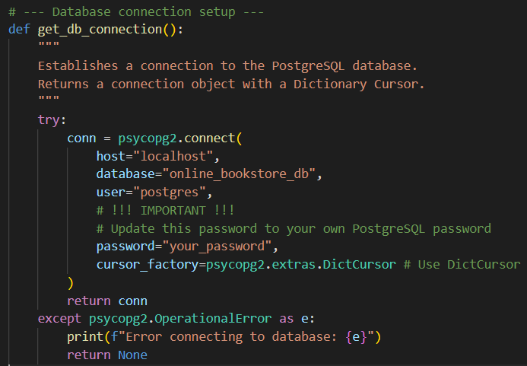
CODE
Figure 1.1: Flask Database Connection Setup (get_db_connection).

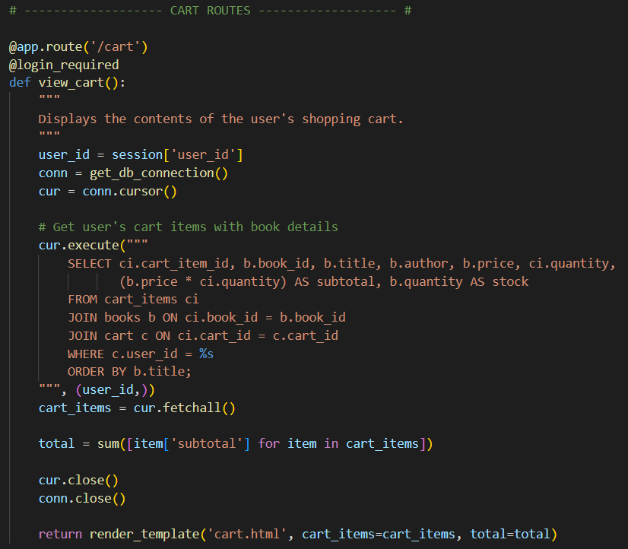
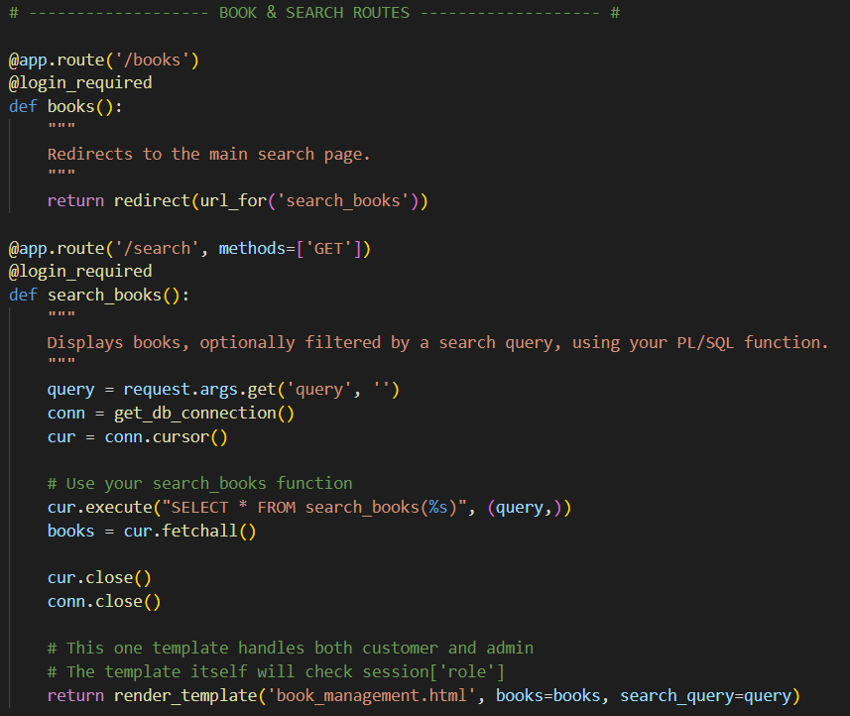
Figure 1.3: Flask Route for Viewing the Shopping Cart (/cart).
Figure 1.2: Flask Route for Book Searching and Browsing (/search).
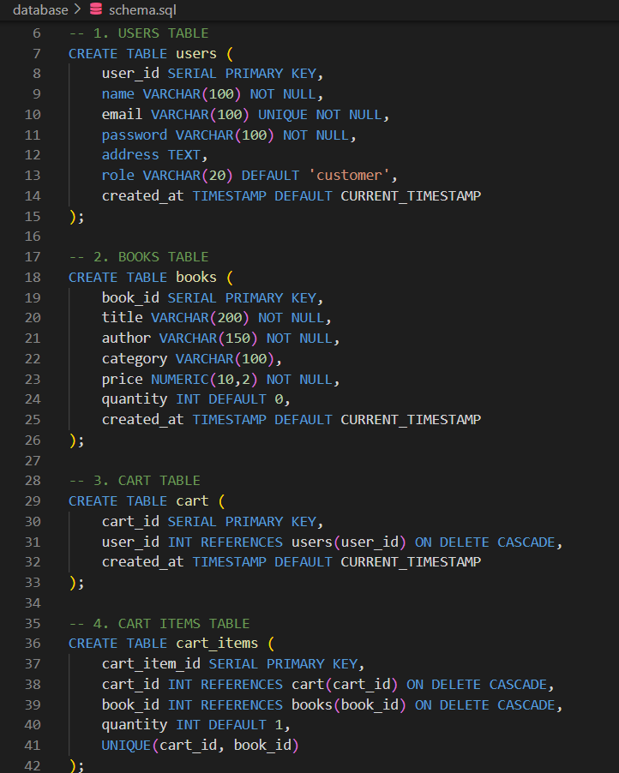
Figure 2.1: Database Schema (schema.sql).

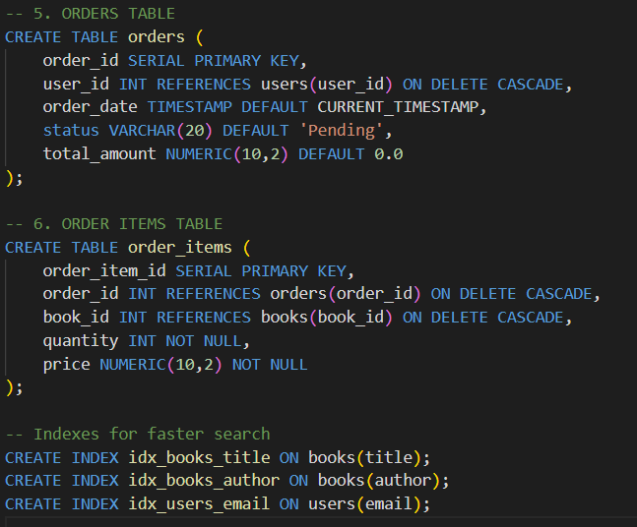
Figure 2.2: Orders and Order Items Tables (schema.sql).
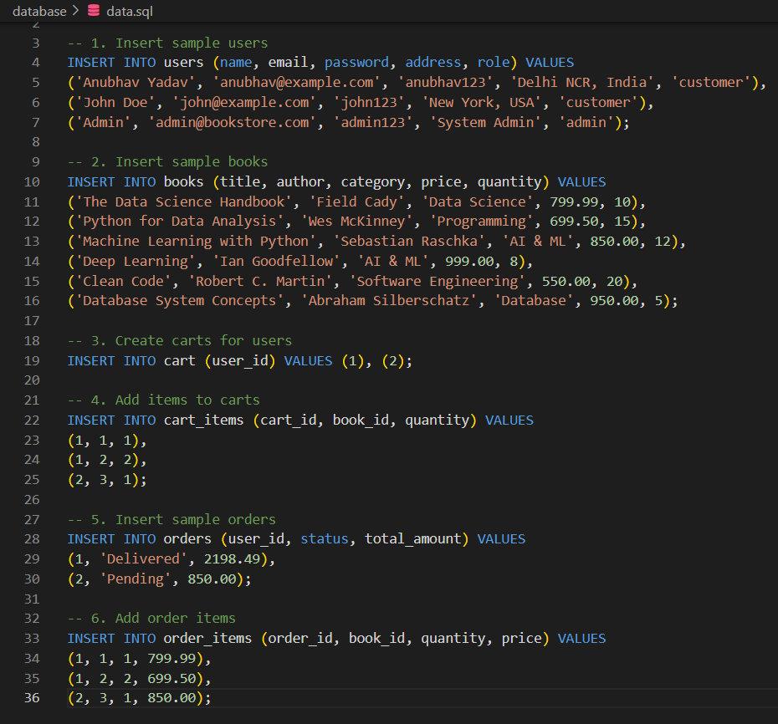
Figure 2.3: Sample Data (data.sql).
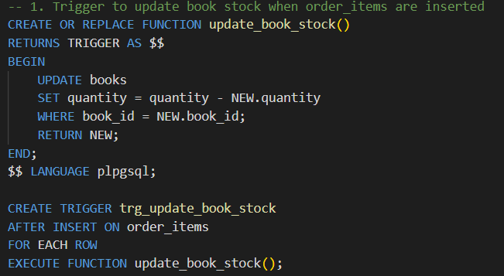
Figure 3.1: Trigger for Automatic Stock Reduction (trg_update_book_stock)
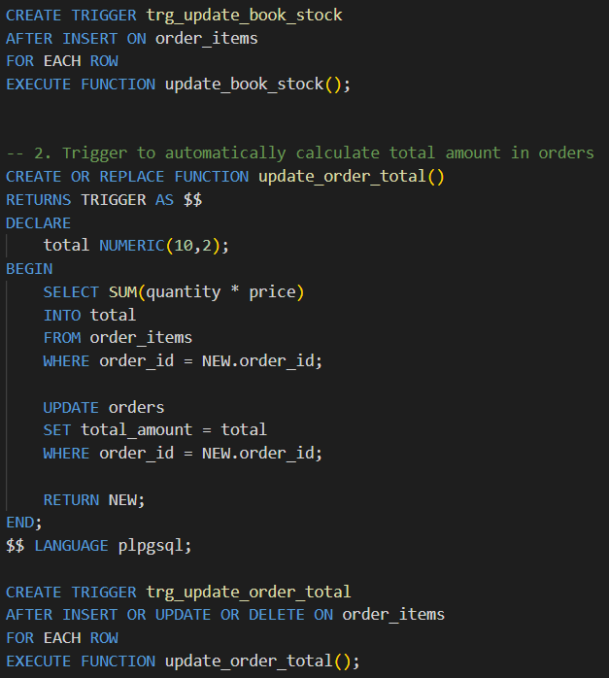
Figure 3.2: Trigger for Order Total Calculation (trg_update_order_total)
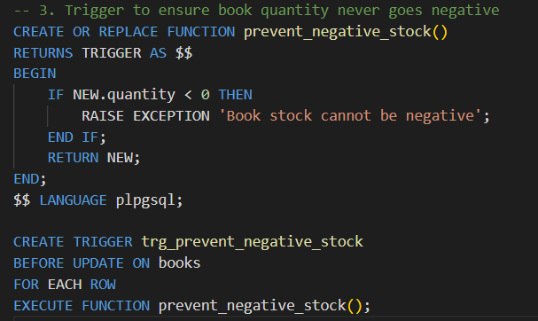
Figure 3.3: Trigger for Negative Stock Prevention (trg_prevent_negative_stock)

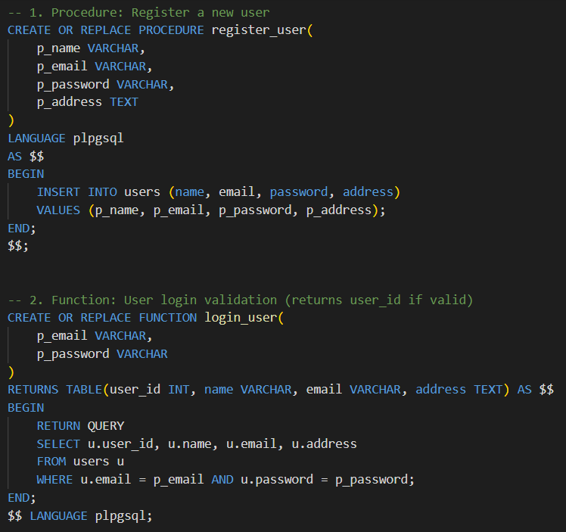
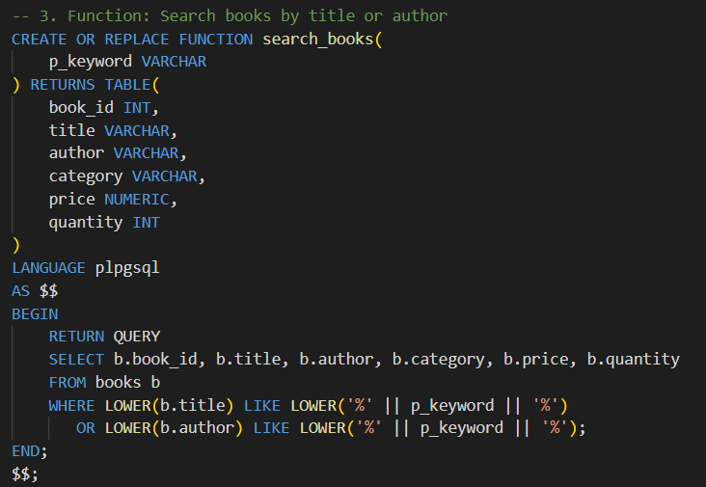
Figure 4.1: PL/pgSQL Procedure for User Registration (register_user) and Login (login_user)
Figure 4.2: PL/pgSQL Function for Searching Books (search_books)

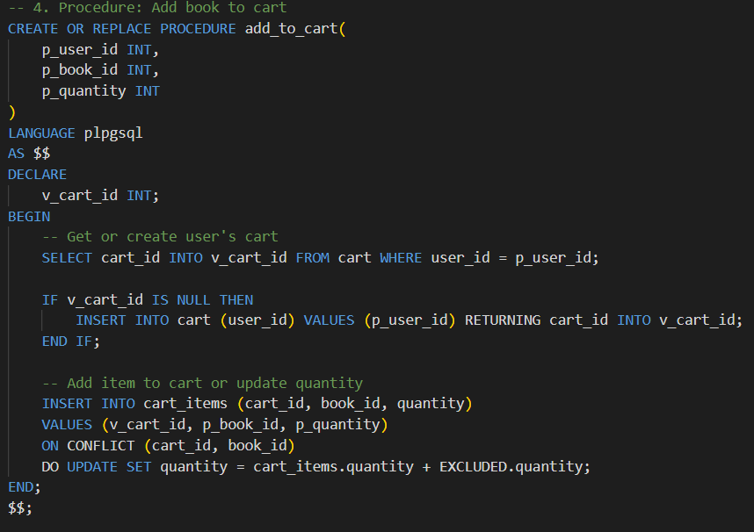
Figure 4.3: PL/pgSQL Procedure for Adding to Cart (add_to_cart)
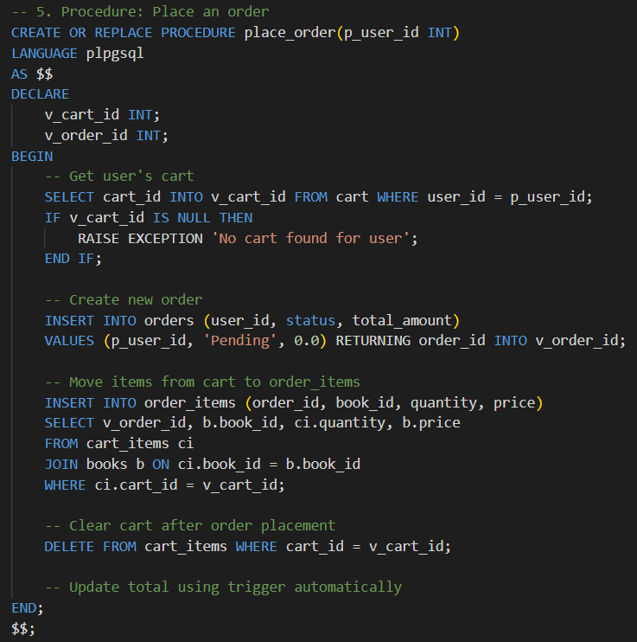
Figure 4.4: PL/pgSQL Procedure for Placing an Order (place_order)
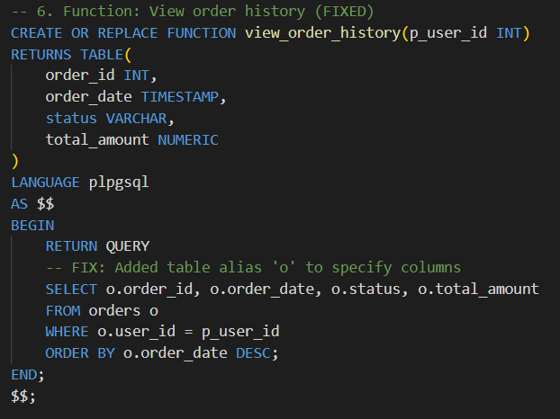
Figure 4.5: PL/pgSQL Function to View Order History (view_order_history)

RESULTS AND VISUALIZATION
The Online Bookstore Management System was successfully implemented as a web application using the Flask framework and a PostgreSQL database. All functional and non-functional requirements were met, demonstrating the effective integration of front-end UI with secure, procedure-driven database logic.

Key Project Results

Core Transactional Integrity via PL/pgSQL
The most significant achievement is the successful delegation of critical business logic to the database layer, ensuring atomic transactions:
- Automated Stock Management: The system successfully uses database Triggers to automatically decrement the quantity of a book in the books table the instant an item is inserted into the order_items table.
- Order Atomicity: The place_order stored procedure correctly manages the entire checkout process—creating the order, transferring items, and clearing the cart—as a single, robust transaction.
- Security Enforcement: The prevent_negative_stock trigger successfully prevents any data manipulation from resulting in book quantities below zero, enforcing critical business constraints.

Fully Functional E-commerce Loop
The application provides a complete and reliable end-to-end purchasing experience for the customer:
- User Profiles: Users can log in, securely maintain a session, and view their personalized order history, including itemized order details.
- Dynamic Cart: The shopping cart correctly stores and calculates subtotals and totals in real-time.
- Admin Control: Administrators gain full CRUD (Create, Read, Update, Delete) access to the book inventory, allowing for real-time stock and pricing adjustments.

Data-Driven Reporting
The system provides a clear administrative dashboard, built entirely from PL/pgSQL functions, giving instant business intelligence:
- Best-Seller Identification: Reports successfully aggregate sales data to identify and rank books by revenue and units sold.
- Proactive Inventory: The low-stock report provides administrators with a direct list of items needing replenishment, increasing operational efficiency.

Visualization of the System
The following visualizations demonstrate the application's responsive, data-driven interface and the administrative reporting features.

Customer Interface (Book Browsing)
The main interface allows customers to easily search the catalog and add products to their cart. The design is clean and responsive, ensuring usability on any device.
Element | Description
Header | Always shows the cart count and profile link when logged in.
Search | Filters results instantly by Title or Author using the search_books database function.
Table | Displays current stock, price, and the "Add to Cart" action button.

Administrative Reporting Dashboard
Accessed exclusively by the Admin role, this page utilizes data fetched from the custom PostgreSQL reporting functions to provide actionable business insights.
Report Category | Key Data Visualized | Source
Key Metrics | Total Revenue, Total Orders, Average Order Value (shown in colored cards). | get_sales_overview function
Best Sellers | List of top 5 books ranked by units sold and revenue generated. | get_best_selling_books and get_top_grossing_books functions
Low Stock | Highlighted list of books with a quantity under 10, prioritizing restock needs. | get_low_stock_books function
OUTPUT:
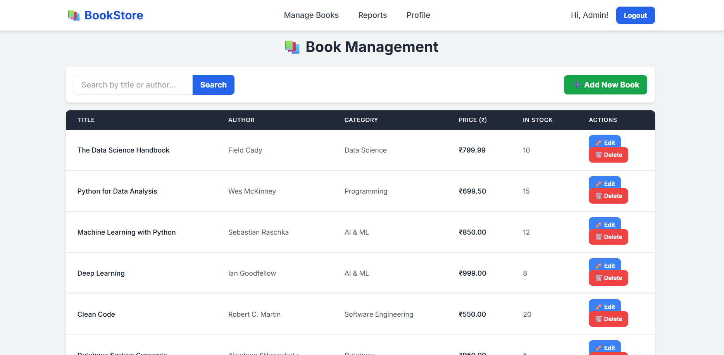
Figure 5.1: Admin Book Management Interface

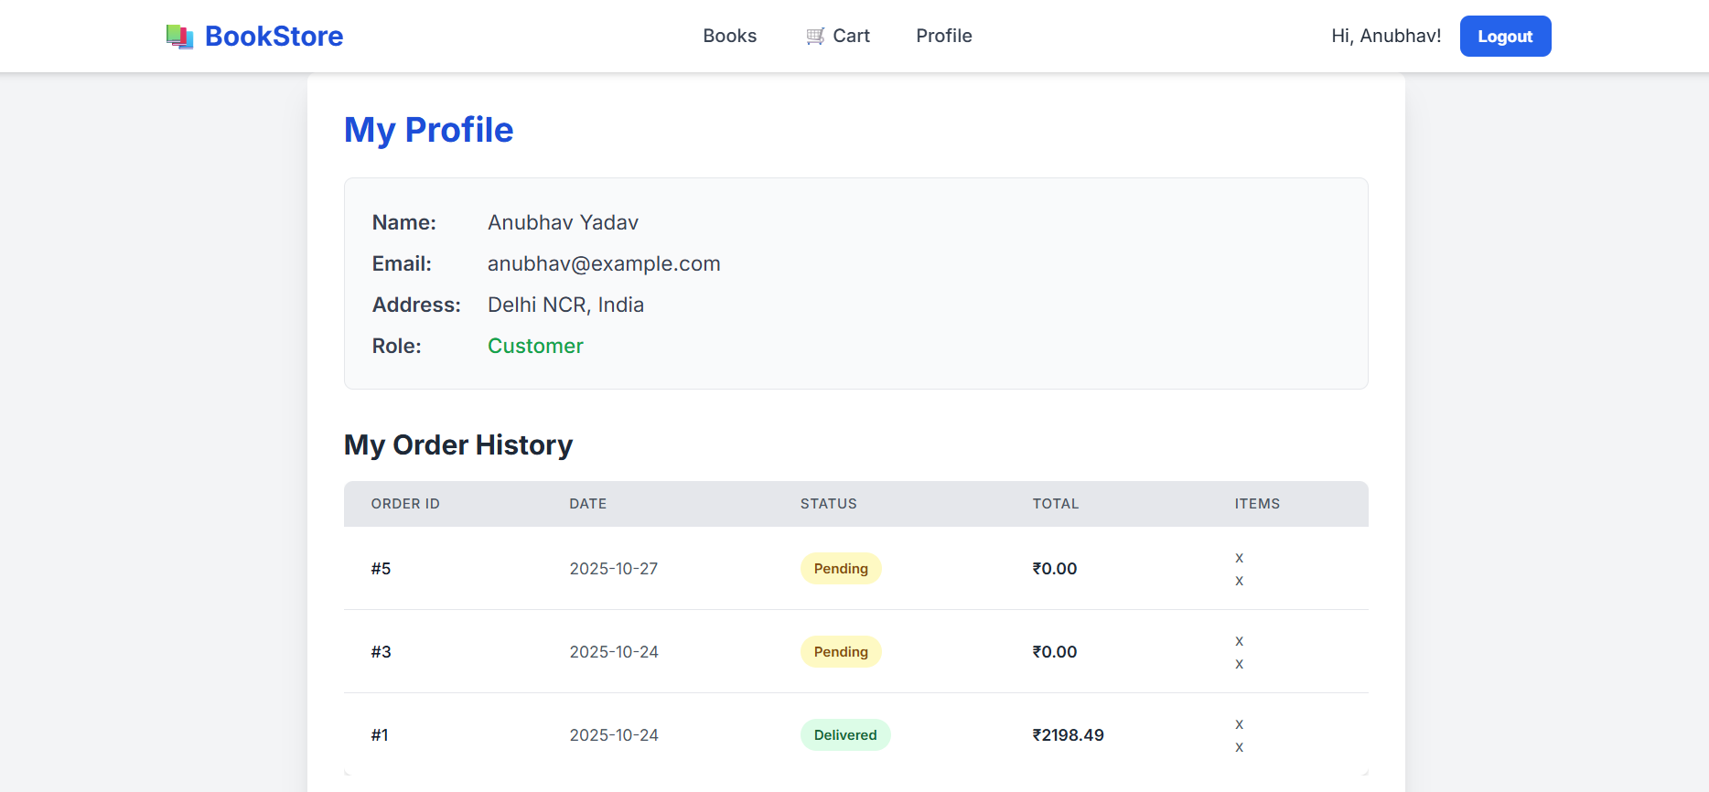
Figure 5.2: Customer Profile and Order History
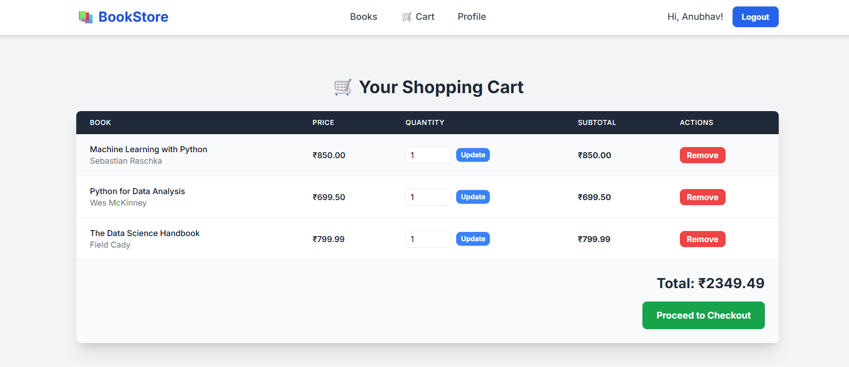
Figure 5.3: Shopping Cart Interface

GitHub Link: https://github.com/AnubhavYadavBCA25/PL-SQL-Mini-Project-Sem-1

REFERENCES
This project integrates technologies from several fields, including web development, relational database management, and server-side scripting. The following resources informed the architectural choices and technical implementation:

I. PostgreSQL and Database Programming (PL/pgSQL)
- Chamberlin, D. D., & Boyce, R. F. (1974). SEQUEL: A structured English query language. Proceedings of the 1974 ACM SIGMOD workshop on Data description, access and control. (Fundamental paper establishing SQL principles).
- PostgreSQL Global Development Group. (2025). PostgreSQL Documentation, 17: Procedural Language PL/pgSQL. (Official reference for writing stored procedures, functions, and triggers to enforce business logic and ensure transactional integrity).
- Stonebraker, M., & Hellerstein, J. M. (2005). What goes around comes around. Readings in Database Systems (4th ed.). (Discusses the shift of logic from the application tier to the database tier, justifying the use of PL/pgSQL for critical transactions).

II. Python and Flask Framework (Application Logic)
- Armin Ronacher. (2025). Flask Documentation (2.x). The Pallets Project. (Official guide for the micro-framework used to manage routing, user sessions, and middleware for the web application).
- McKinney, W. (2017). Python for Data Analysis: Data Wrangling with Pandas, NumPy, and IPython (2nd ed.). O'Reilly Media. (Relevant for Python programming practices and data handling, specifically how the Flask routes process data before querying the database).
- Brewer, E. A. (2000). Towards robust distributed systems (Brewer’s Conjecture). Proceedings of the nineteenth annual ACM symposium on Principles of distributed computing. (Conceptual foundation for the need of the application layer to handle availability and partition tolerance, while the database manages consistency).

III. Web Development and Standards (UI/UX)
- W3C. (2025). Cascading Style Sheets (CSS) Current Status. World Wide Web Consortium. (Reference for modern styling principles used to create the responsive user interface).
- The Tailwind CSS Team. (2025). Tailwind CSS Documentation. (Used for utility-first styling to ensure a clean, modern, and mobile-responsive design for all HTML templates).
- Nielsen, J. (1993). Usability Engineering. AP Professional. (Foundational principles guiding the development of the user-friendly interface, focusing on ease of navigation, especially for the cart and checkout processes).

